**“CLICK - AI Virtual Mouse ”**

*ChangeLog*

|  |  |  |  |
| --- | --- | --- | --- |
| **Version** | **Change Date** | **By** | **Description** |
| version number | Date of Change | Name of person who made changes | Description of the changes made |
|  |  |  |  |
|  |  |  |  |

1. INTRODUCTION 1
   1. SCOPE 1
      1. In Scope 2
      2. Out of Scope 2
   2. QUALITY OBJECTIVE 2
   3. ROLES AND RESPONSIBILITIES 3
2. TEST METHODOLOGY 4
   1. OVERVIEW 4
   2. TEST LEVELS 4
   3. TEST COMPLETENESS 4
3. TEST DELIVERABLES 5
4. RESOURCE & ENVIRONMENT NEEDS 7
   1. TESTING TOOLS 7
   2. TEST ENVIRONMENT 8
5. TERMS/ACRONYMS 8

# Introduction

“ Click - AI virtual mouse ” is a project which enables the user to operate the cursor without using mouse , just by face . In this project cursor moves by moving our eyes while the click implements by saying “tap” with your mouth. The project is build by using ML as the main instrument . mediapipe performed the implementation of ML. Python libraries such as - numpy , autopy were used to process numerics , images and videos.

## Scope

### In Scope

The main feature of the software is to identify a particular object ,such as eye, fingers etc.ML is used to implement this task .the 2nd most significant feature of the software is to interlink the frames of the camera with the computer screen and identify the X and Y coordinates .

The functional requirement of the software are -

a- eye detection

b- eye movement detection

c- 2 points distance calculator

d- out of bound detection

e - connecting the camera with mouse .

Non functional requirements -

a- error handling

b- compatibility test

c- Edge cases

### Out of Scope

1- compatibility with mobile platform

2- multiple face recognition

3- gesture control

4- Filters and effects

## Quality Objective

**The project underwent rigorous quality assurance measures to ensure its accuracy, performance, usability, and overall effectiveness. These efforts encompassed various aspects:**

* Accuracy Assessment
* Performance Optimization
* Usability Testing:
* Security and Privacy:
* Robustness and Reliability:
* Scalability:
* User Feedback Incorporation

## Roles and Responsibilities

Detail description of the Roles and responsibilities of different team members like

* QA Analyst
* Test Manager
* Configuration Manager
* Developers
* Installation Team

Amongst others

# Test Methodology

## Overview

The test methodology selected for the project could be

* Iterative
* Iterative method is used because of the complicated functionality of the software . As the new lines of codes sometimes nullify the previous ones.

## Test Levels

We aim to test our project at the following levels:

1. Unit Testing: This is the lowest level of testing and focuses on individual components or functions within the software. Developers often perform unit tests to verify that specific parts of the code work correctly.
2. Integration Testing: This level of testing checks how different components or modules of the software work together. It ensures that integrated parts of the software function as intended.
3. System Testing: At this level, the entire system is tested as a whole. It verifies that the software meets its specified requirements and functions properly in its intended environment.

## Test Completeness

* 100% test coverage
* All Manual & Automated Test cases executed
* All open bugs are fixed or will be fixed in next release

# Test Deliverables

Here mention all the Test Artifacts that will be delivered during different phases of the testing lifecycle.

Here are the sample deliverables

|  |
| --- |
| * Test Plan * Test Cases |

# 

# Test Cases

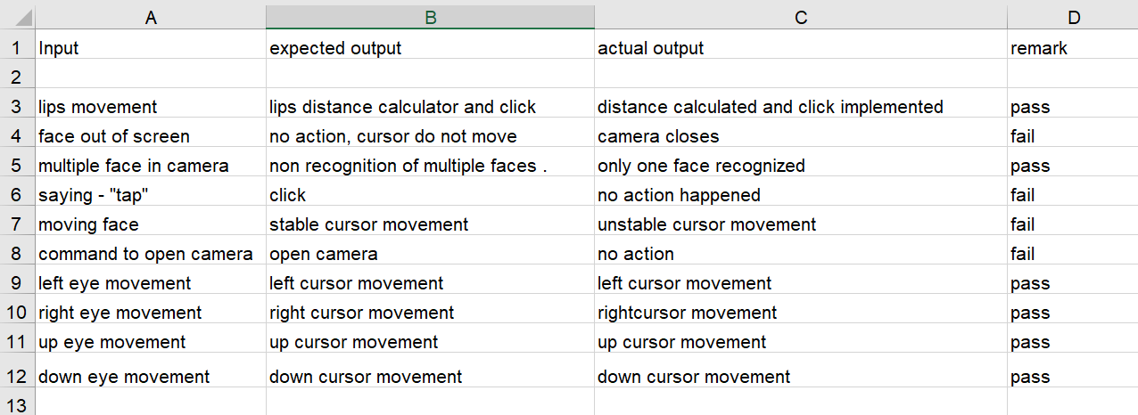

## Decision Table:

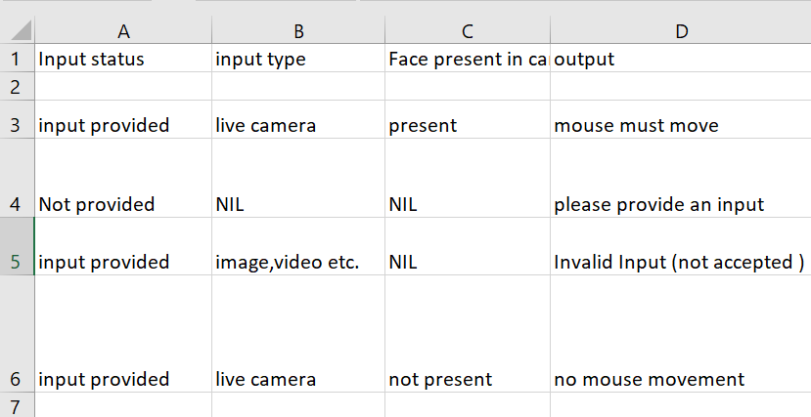

Decision Tree :

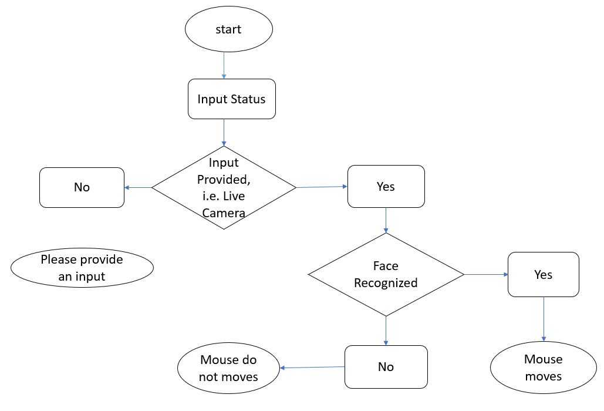

# 5 Resource & Environment Needs

## Testing Tools

Manual testing has been performed .

## Test Environment

Following **software’s** are required in addition to client-specific software.

* Windows 8 and above
* open CV
* Python IDE
* python libraries -Numpy , Autopy.

# 6 Terms/Acronyms

Make a mention of any terms or acronyms used in the project

|  |  |
| --- | --- |
| **TERM/ACRONYM** | **DEFINITION** |
| API | Application Program Interface |
| AUT | Application Under Test |